ONLINE LIBRARY MANAGEMENT SYSTEM
PROJECT REPORT
ON
“ONLINE LIBRARY MANAGEMENT SYSTEM”



Submitted by - Guided By-
Rushabh Wadkar Prof. Pradip Kakde
(SID – S161109800053) Professor at NIIT,Panvel
(RID – R161109800192)

Acknowledgement

The satisfaction that accompanies the successful completion of any task would be incomplete without the mention of people whose ceaseless cooperation made it possible, whose constant guidance and encouragement crown all efforts with success.

I am very grateful to my project guide Prof. Pradip Kakde for the guiding, inspiring and providing constructive suggestions that helped me in the preparation of this project.
I also thank Bhavesh Singh who also helped in some ways for the successful completion of the project.

CERTIFICATE

This is to certify that this report of Online Library Management
System embodies the original work done by
Rushabh Wadkar
Student ID – S16110980053
Registeration ID – R161109800192

during this project submission as a partial fulfilment of the requirement for the Course CJEI5 at NIIT.

Pradip Kakde
Professor
NIIT Panvel

Table of Contents

- Synopsis 5
- Feasibility Study 7
- Data Flow Diagrams 8
- Entity Relationship Diagram 9
- Class Diagram 11
- Use case 12
- Activity Diagram 13
- Sequence Diagram 14
- Screen Shots Of Form 15
- Future Scope 22
- Conclusion 24
- Bibliography 25

Synopsis

- Introduction
  - Purpose –

The Purpose of this application are as follows :
- The software is for automation of library.
- It provides following facilities to

Student:
- Can issue and return books.
- Can see the pending requests.
Admin:
- Can read and write information about any member.
- Can update, create, and delete the record of any membership as per requirement and implementation.
- Can grant or revoke any request (issue or return) from student.

2.) Scope:
The different areas where we can use this application are:
- Any education institute can make use of it for providing information about author, content of the available books.
- It can be used in offices and modifications can be easily done according to requirements.
3.) Technology Used:
- Front End: JSP, Servlets, JQuery, CSS, HTML, Java script.
- Back End: MYSQL DERBY SERVER, GLASHFISH.
4.) Assumptions
- This application is used to convert the manual
- Application to the online application.
- Customized data will be used in this application.
- User does not have right to enter information about books.
5.) Overview:
- Project is related to library management which provides
- Reading services to its members. Any person can become a member of the library by filling a prescribed form.
- They can get the book issued, so that they can take home and return them.
6.) Functionality:
- Online membership.
- Keeps the track of issues and submission of books.

Feasibility Study

In feasibility study phase we had undergone through various steps which are describe as under:
1. Identify the origin of the information at different level.
2. Identify the expectation of user from computerized system.
3. Analyse the drawback of existing system (manual) system.

Data Flow Diagram

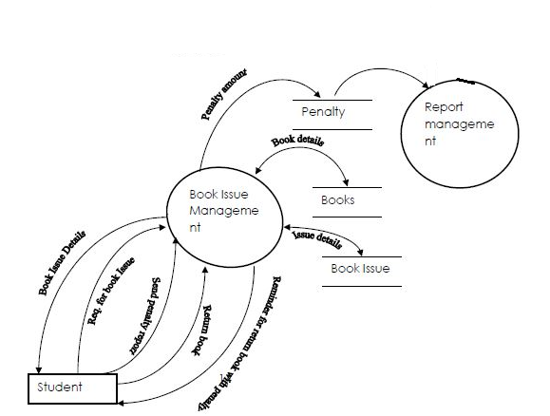

E-R DIGRAM
It is clear that the physical objects from the previous section
– The member, books, library – correspond to entities in the
Entity-Relationship model, and the operations to be done on those entities – holds, checkouts, and so on – correspond to relationships. However, a good design will minimize redundancy and attempt to store all the required information in as small a space as possible.

Class Diagram:

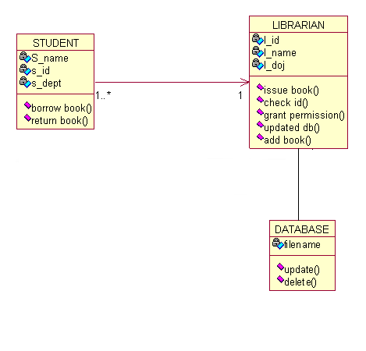

Use Case Diagram:

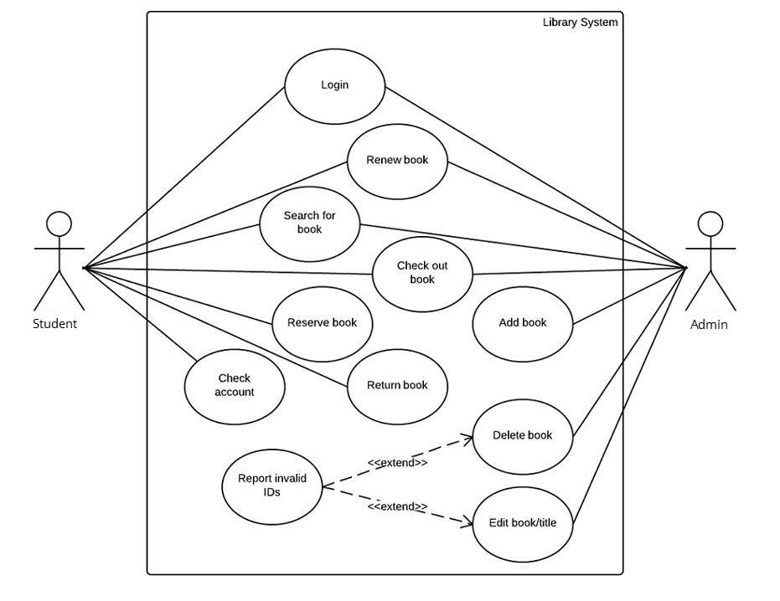

Activity Diagram:

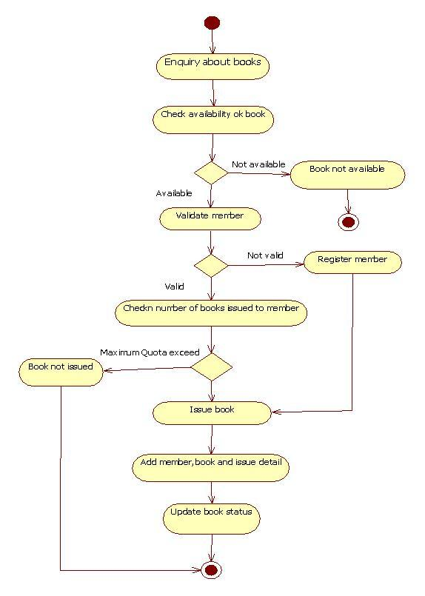
Sequence Diagram:
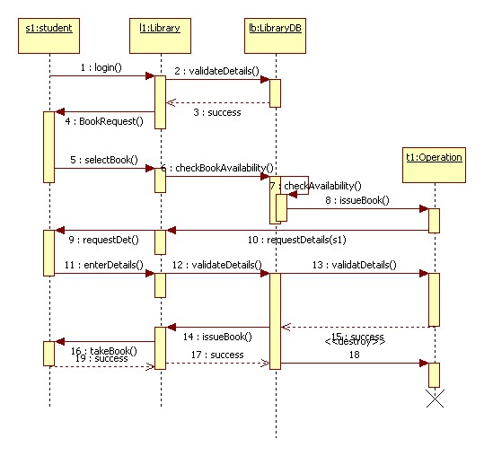

Snapshots –
Login Page for Admin and Students

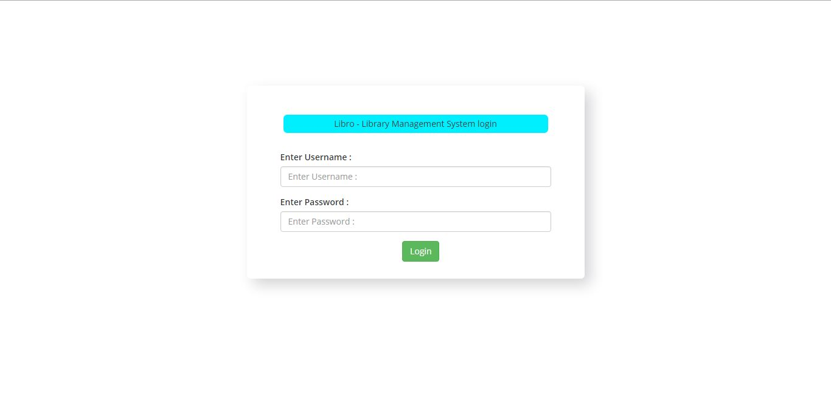

Admin Dashboard
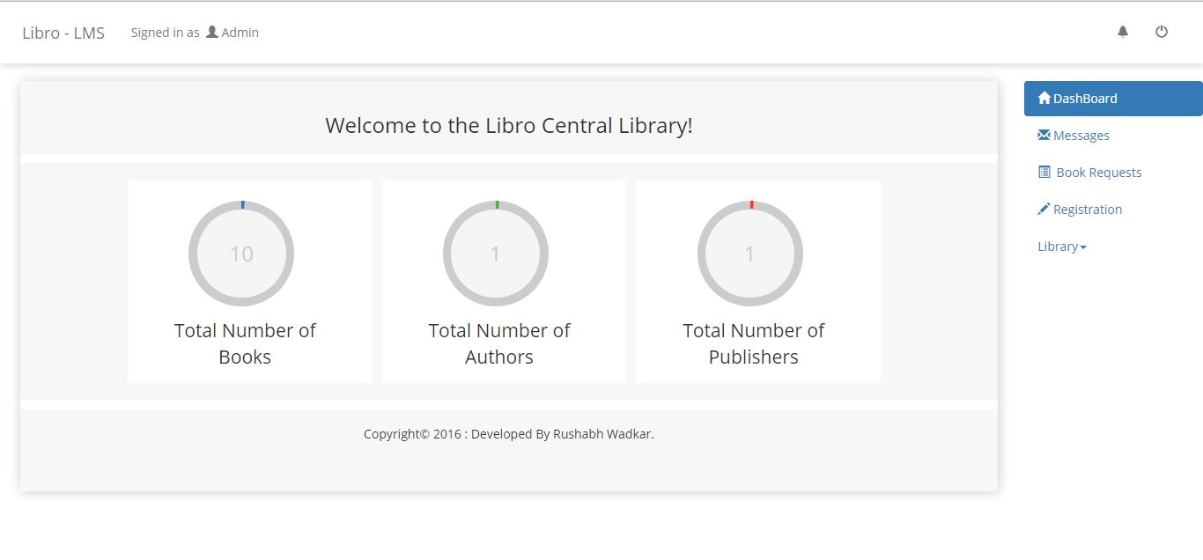
Registration Page
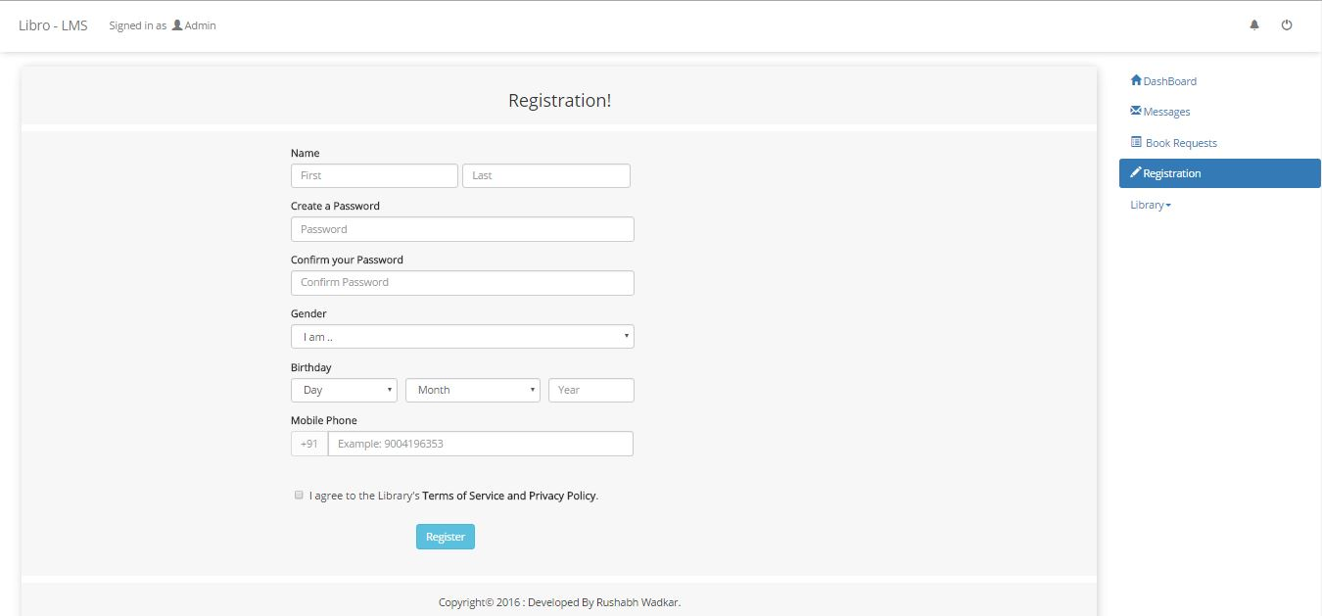

Adding Books Page
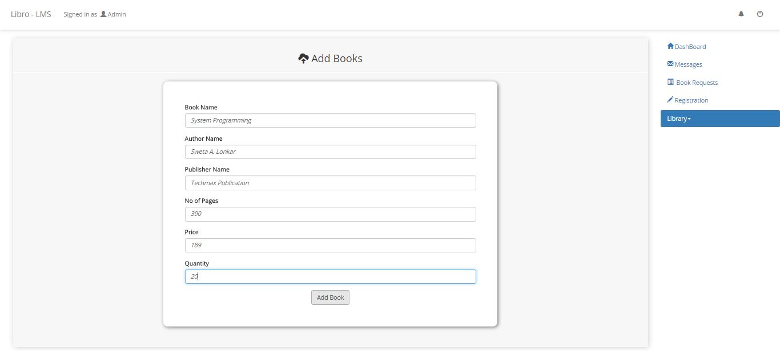

View Page
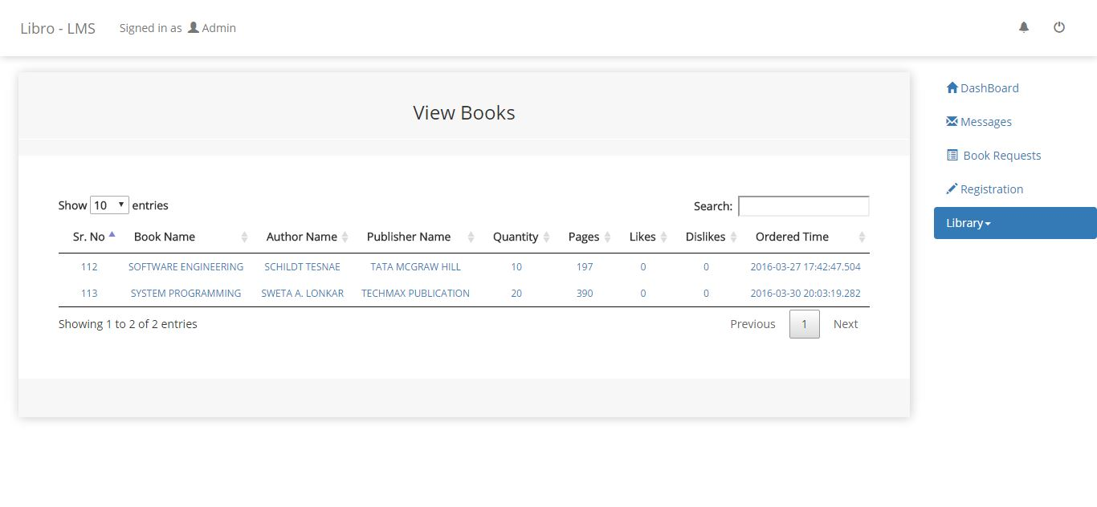

Book Details Page
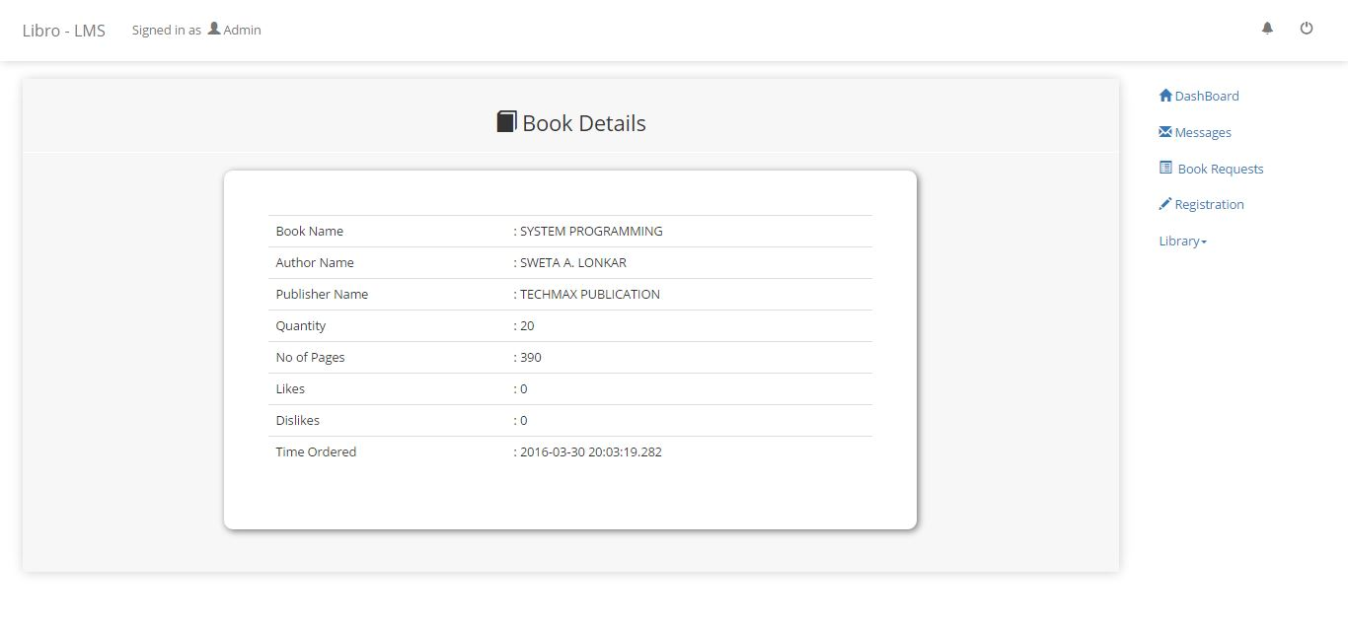
Delete Book Page
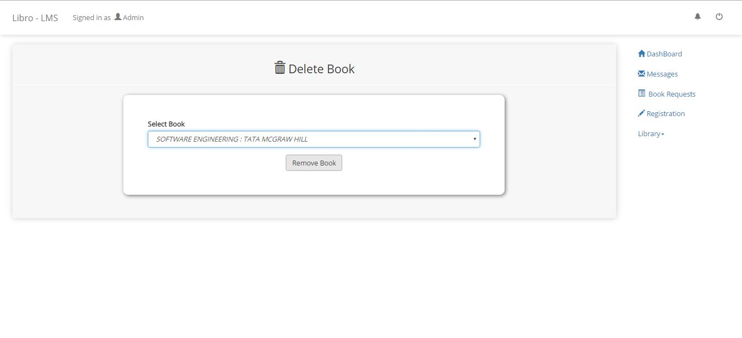

Issue Book Page
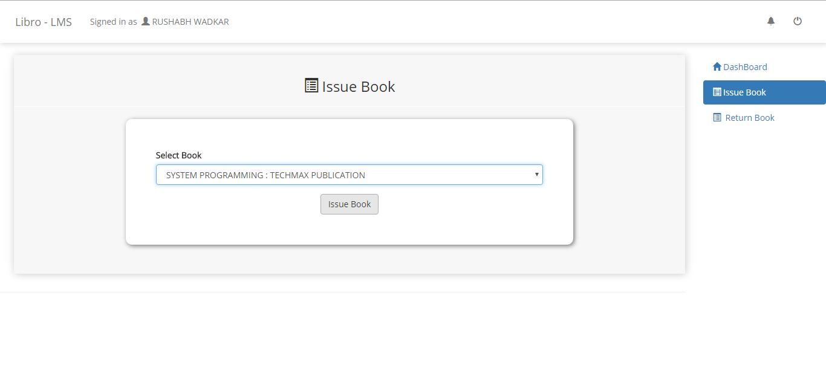

Student Dashboard Page
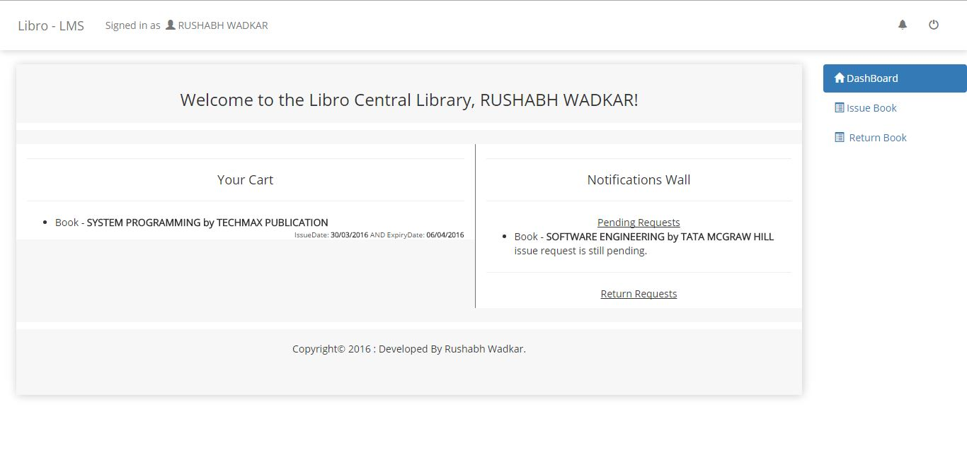

Return Book Page
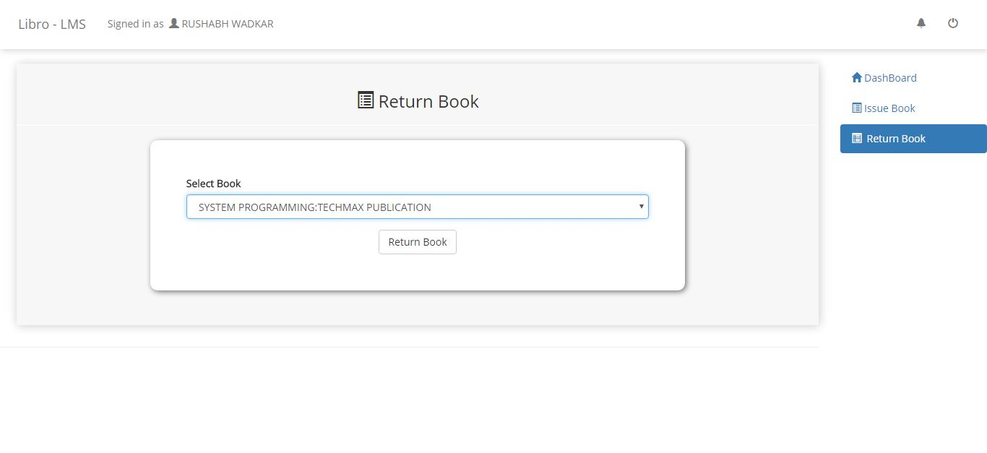

Requests Section Page
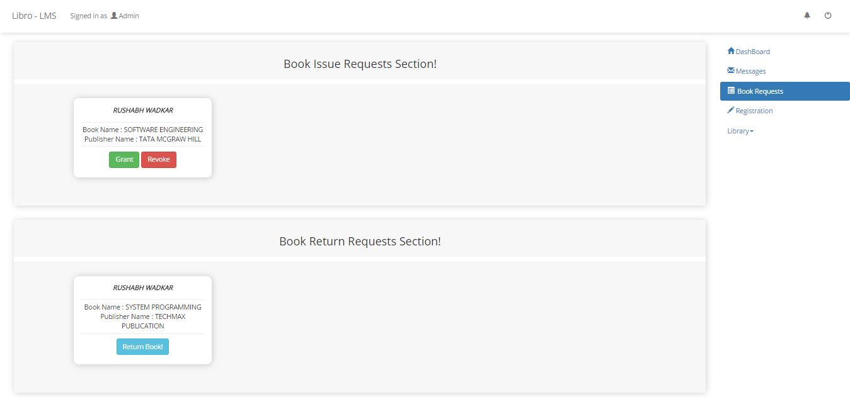

Future Scope

FUTURE SCOPE OF APPLICATION:
This application can be easily implemented under various situations.
We can add new features as and when we require. Reusability is possible as and when require in this application. There is flexibility in all the modules.

SOFTWARE SCOPE:
- Extensibility: This software is extendable in ways that its original developers may not expect. The following principles enhances extensibility like hide data structure, avoid traversing multiple links or methods, avoid case statements on object type and distinguish public and private operations.
- Reusability: Reusability is possible as and when require in this application. We can update it next version. Reusable software reduces design, coding and testing cost by amortizing effort over several designs. Reducing the amount of code also simplifies understanding, which increases the likelihood that the code is correct. We follow up both types of reusability: Sharing of newly written code within a project and reuse of previously written code on new projects.
- Understandability: A method is understandable if someone other than the creator of the method can understand the code (as well as the creator after a time lapse). We use the method, which small and coherent helps to accomplish this.
- Cost-effectiveness: Its cost is under the budget and make within given time period. It is desirable to aim for a system with a minimum cost subject to the condition that it must satisfy the entire requirement.

Scope of this document is to put down the requirements, clearly identifying the information needed by the user, the source of the information and outputs expected from the system.

Conclusion

From a proper analysis of positive points and constraints on the component, it can be safely concluded that the product is a highly efficient GUI based component. This application is working properly and meeting to all user requirements. This component can be easily plugged in many other systems.

Bibliography

Books:
• Web Component Development with Servlet and JSPTM Technologies by NIIT

Web Sites:
- www.tutorialspoint.com
- www.javatpoint.com
- www.stackoverflow.com

